This report aims to summary the related work of our ongoing project and gives a first vision of our simulation plan.

Our project wants explore what will bring to the power line in community where users have different pricing model. In another word, if users use different pricing model, how will it affect the total consumption of the power line from the community level point of view.

Before we dig into details, we have to know the types of existing electricity pricing mode, and what users can do to take advantage of the pricing model they are using. In following report, we’ll talk about three types of pricing model: 1) fixed pricing model; 2) TOU (time-of-use) pricing mode and 3) real-time pricing model, then we’ll introduce two main scheduling strategies, which can help users to cut their electricity bills, such as Smart Charge and Smart Cap.

**Different Pricing Model**

Currently, electricity companies can offer users many billing plans. The simplest one is **fixed pricing model** which allows you to lock in the price of your electricity for a predetermined period of time from a few months up to a few years. You can plan your energy spend and know how much it will cost in the future. If the price of energy goes up, you save money by paying a lower price for energy than current market rates. However, if the price of energy falls, you are locked into that higher rate for the period of the contract and could miss out on an opportunity for energy cost savings. For different electricity suppliers, the prices of this fixed plan could vary from 6.4 to 11 cents/kWh for the same city. Use following link, you can check your local fixed billing rate of different electricity suppliers.

<https://www.chooseenergy.com/compare/13905/electricity-rates/>,

**TOU pricing model** means electricity prices are set for a specific time period on an advance or forward basis, typically not changing more often than twice a year. Prices paid for energy consumed during these periods are pre-established and known to consumers in advance, allowing them to vary their usage in response to such prices and manage their energy costs by shifting usage to a lower cost period or reducing their consumption overall. Here is an example of TOU pricing model from [Portland General Electric](http://www.portlandgeneral.com/).

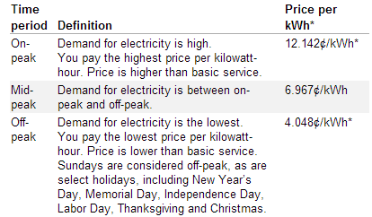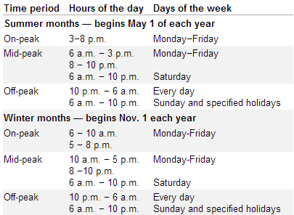

For better understanding, there is a picture of 2 TOU pricing models.

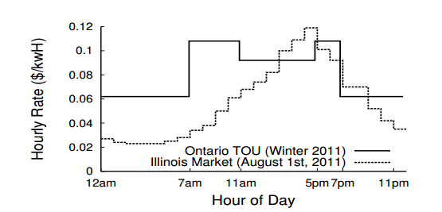

**The real-time pricing model** that use real-time or day-ahead hourly electricity price offer residential customers an innovative choice in how they pay for power. Fluctuated Price reflects the [utility](http://en.wikipedia.org/wiki/Utility)’s cost of generating and/or purchasing electricity at the wholesale level. The advantage of this pricing plan is that you can control energy costs by scheduling activities when electric rates are at their lowest (more detail can be seen in Wikipedia “[demand response](http://en.wikipedia.org/wiki/Demand_response)”). Here is a picture of real-time pricing model.

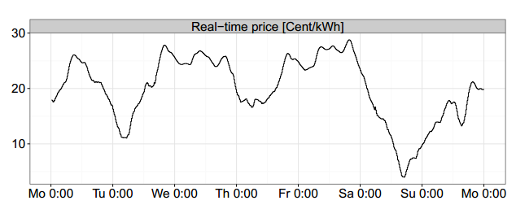

For more real world information, you can visit following link:

<http://www.elevateenergy.org/home-savings/dynamic-pricing-smart-grid/>

**Energy Scheduling Strategies**

If users know which type of pricing model they are using, they’ll know the exact price at any specific time. So, they can leverage some strategies to decrease their bills.

For fixed pricing model, in my opinion, there is few things we can do, since the price is fixed, users just pay how much they used. Of course, decreasing unnecessary consumption (such as turning off the light when leaving the room) can help users to save some money, but this is common sense. Also, if customers can predict the electricity market, they can cut the bill by signing a long contract when the price of electricity keeps increasing or signing a relatively short contract when the price may drop. But I don't know whether there is an accurate way to predict the electricity market. Is the electricity market just like other energy markets such as oil or coal? Feel free to correct me if I was wrong.

For dynamic pricing model: TOU and real-time pricing model, researchers in energy area have proposed several strategies and tons of paper. Generally, there are two categories: 1) leveraging external battery and 2) scheduling electrical appliances.

**Leveraging External Battery**

By implementing this approach, users need to purchase an external battery and use it as an additional power supply. Users will charge the battery when the price of electricity is low, such as midnight or early morning, and discharge the battery when the price is high. So, the point of this approach is to decide when to switch the home’s power supply between power grid and battery. However, there are several concerns about this approach: 1) the battery is not cheap, if users want use battery to cover the whole high-price period, the initial investment could be huge, 2) there exists conversion loss during battery charging and discharging states, 3) the charging and discharging rate is limited, 4) the lifetime of battery can quickly decrease due to frequently charging and discharging, and 5) if all users follow the same strategy, which will result in high peak consumption in low-price period and make the price model reverse.

For more detailed information, you can google following references:

[***Aditya Kumar Mishra***](http://www.informatik.uni-trier.de/~ley/pers/hd/m/Mishra:Aditya_Kumar.html)***, David E. Irwin, [Prashant J. Shenoy](http://www.informatik.uni-trier.de/~ley/pers/hd/s/Shenoy:Prashant_J=.html),***[***Jim Kurose***](http://www.informatik.uni-trier.de/~ley/pers/hd/k/Kurose:James_F=.html)***,***[***Ting Zhu***](http://www.informatik.uni-trier.de/~ley/pers/hd/z/Zhu:Ting.html)***: SmartCharge: cutting the electricity bill in smart homes with energy storage.***[***e-Energy 2012***](http://www.informatik.uni-trier.de/~ley/db/conf/eenergy/eenergy2012.html#MishraISKZ12)***: 29***

***A. Bar-Noy, Y. Feng, M. Johnson, and O. Liu. Whento Reap and When to Sow: Lowering Peak Usage With Realistic Batteries. In WEA, June 2008.***

***A. Bar-Noy, M. Johnson, and O. Liu. Peak Shaving Through Resource Buffering. InWAOA, September 2008.***

***T. Carpenter, S. Singla, P. Azimzadeh, and S. Keshav. The Impact of Electricity Pricing Schemes on Storage Adoption in Ontario. In e-Energy, May 2012***

***I. Koutsopoulos, V. Hatzi, and L. Tassiulas. Optimal Energy Storage Control Policies for the Smart Power Grid. In SmartGridComm, September 2011.***

**Scheduling Electrical Appliances**

The main idea of this approach is to schedule the appliance usage to lower price period. However there are several limitations of this approach: 1) vast majority of household electrical loads are interactive and have little scheduling flexibility such as microwave oven, TV etc., scheduling these kinds of appliances will affect user’s life pattern which may make users unhappy, 2) scheduling some appliances requires active consumer involvement during peak periods, such as turning off unnecessary lights, programming a thermostat, or postponing washing clothes, which is troublesome and 3) a substantial fraction of home energy use derives from background loads, which has limited flexibility, such as A/Cs, refrigerators, and dehumidifiers, but if these kinds of appliance are not scheduled well, this may impact users’ comfort level.

For more detailed information, you can google following references:

[***Sean Kenneth Barker***](http://www.informatik.uni-trier.de/~ley/pers/hd/b/Barker:Sean_Kenneth.html)***, [Aditya Kumar Mishra](http://www.informatik.uni-trier.de/~ley/pers/hd/m/Mishra:Aditya_Kumar.html), David E. Irwin, [Prashant J. Shenoy](http://www.informatik.uni-trier.de/~ley/pers/hd/s/Shenoy:Prashant_J=.html),***[***Jeannie R. Albrecht***](http://www.informatik.uni-trier.de/~ley/pers/hd/a/Albrecht:Jeannie_R=.html)***:****SmartCap: Flattening peak electricity demand in smart homes.*[***PerCom 2012***](http://www.informatik.uni-trier.de/~ley/db/conf/percom/percom2012.html#BarkerMISA12)***: 67-75***

***V. Bakker, M. Bosman, A. Molderink, J. Hurink, and G. Smit. Demand Side Load Management Using a Three Step Optimization Methodology. InSmartGridComm, October 2010.***

***S. Keshav and C. Rosenberg. Direct Adaptive Control of Electricity Demand. Technical Report CS-2010-17, University of Waterloo, September 2010.***

***A. Sch¨ ulke, J. Bauknecht, and J. H¨ aussler. Power DemandShifting with Smart Consumers: A Platform for Power Grid friendly Consumption Control Strategies. In SmartGridComm, October 2010.***

**Basic Simulation Plan**

Given a community,

1)100% residents use fixed pricing model, so no one (0%) can take advantage of this unchanged price.

2) 100% residents use TOU pricing model, x% residents don't take any strategy, y% residents use battery-based strategy, and z% resident use appliance-based strategy.(where x + y + z = 100)

3) 100% residents use real-time pricing model, x% residents don't take any strategy, y% residents use battery-based strategy, and z% resident use appliance-based strategy (where x + y + z = 100).

4) a% residents use fixed pricing model, b% residents use TOU pricing model, c% residents use real-time pricing model and all(100%) residents don't take any strategy(where a + b + c =100).

5)a% residents use fixed pricing model, b% residents use TOU pricing model, c% residents use real-time pricing model and all(100%) residents use battery-based strategy (where a + b + c =100).

6) a% residents use fixed pricing model, b% residents use TOU pricing model, c% residents use real-time pricing model and all(100%) residents use appliance-based strategy (where a + b + c =100).

7) a% residents use fixed pricing model, b% residents use TOU pricing model, c% residents use real-time pricing model and x% residents use battery-based strategy, and y% appliance-based strategy (where a + b + c =100 && x + y = 100).

Feel free to add or correct anything.

After you add or correct something, please mark in different font color and send me the updated report.

Thank you.